2. React-JS HOL

Name:- Shubham Sangram Bej

Objective
- Explain React Components.
- Identify the differences between Components and JavaScript Functions.
- Understand Class Components and Function Components.
- Learn the use of the render() method.
- Create multiple React Components and render them.

Software Requirements
- Node.js
- npm
- React
- Visual Studio Code

Project Name
StudentApp

Procedure
- Created a new React application named StudentApp using Create React App.
- Opened the project in Visual Studio Code.
- Created a new folder named Components inside the src directory.
- Created three class components:
  - Home
  - About
  - Contact
- Added suitable welcome messages inside the render() method of each component.
- Imported all three components into App.js.
- Rendered the components inside the main application.
- Applied simple CSS styling to align the contents at the center of the page.
- Executed the application using:
npm start
- Verified the output in the browser.

Output
The application displays the following messages:
- Welcome to the Home page of Student Management Portal
- Welcome to the About page of the Student Management Portal
- Welcome to the Contact page of the Student Management Portal
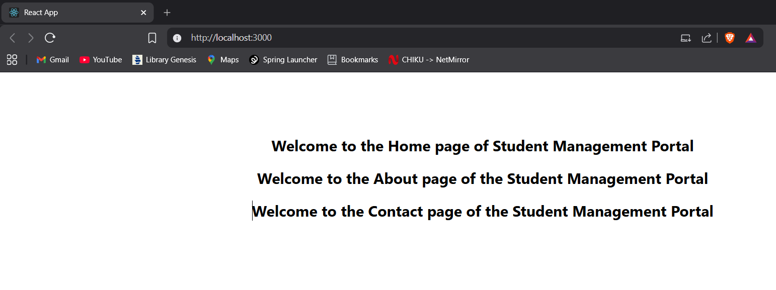

Result
The React application StudentApp was successfully created. Multiple class components were implemented and rendered successfully, displaying the required output.

